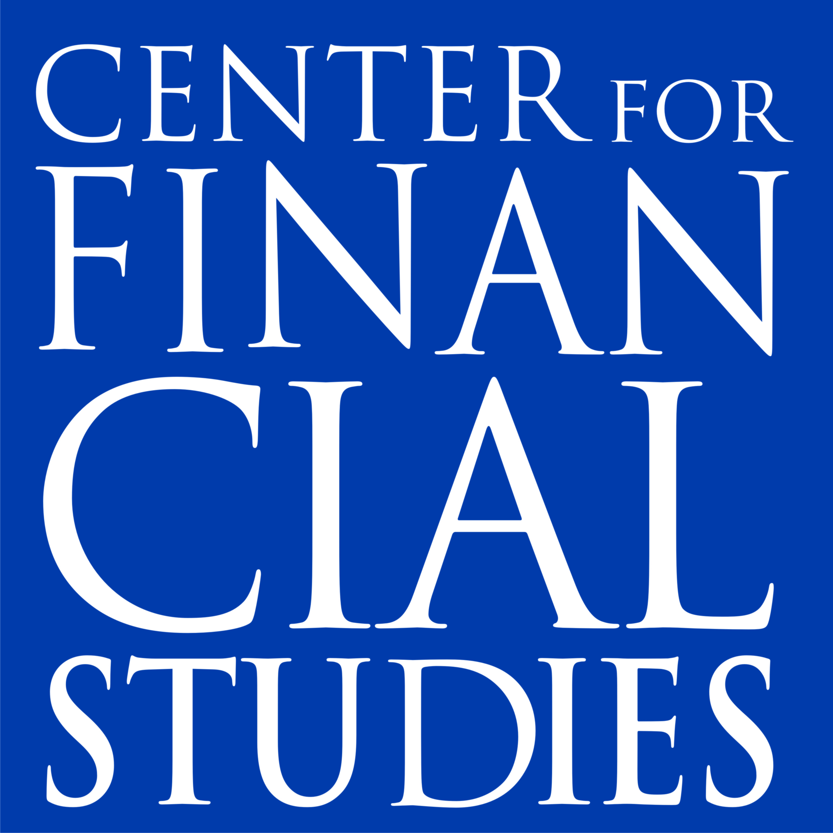
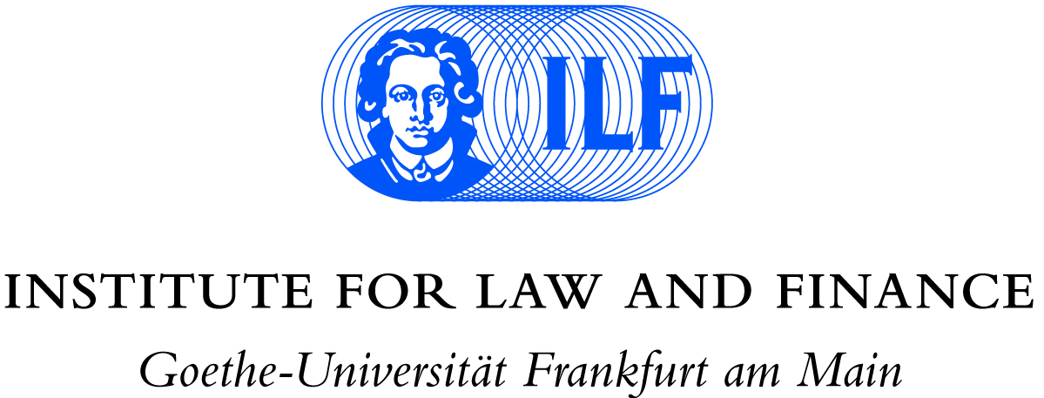
6th Conference on the Banking Union
21 May 2019, Frankfurt am Main

Agenda (draft)
09.30 | Registration and coffee reception
 | Overlapping responsibilities of authorities within the Banking Union
10.00 | Welcome | Andreas Cahn, Executive Director, Institute for Law and Finance
10.15 | 1st speech | Modern banking supervision – leveraging technology to control new risks  Pentti Hakkarainen, Member of the Supervisory Board, European Central Bank (followed by Q&A)
10.45 | 2nd speech | Resolution without borders: progress and challenges  Elke König, Chair of the Single Resolution Board
11.15 | Coffee Break
11.45 | 3rd speech | [Title of presentation TBA]  Saumya Bhavsar , Global Head of Regulatory Affairs, Credit Suisse
12.15 | 1st panel discussion | Elke König, Saumya Bhavsar, Elke Gurlit, Professor of Public Law, Comparative Law and European Law, University of Mainz, and Markus Benzing, Partner, Freshfields Bruckhaus Deringer LLP  Moderator: Christos Gortsos, Professor of Public Economic Law at the Law School of the National and Kapodistrian University of Athens
13.00 | Lunch
 | The digital revolution and supervision
14.00 | 4th speech | How to hit a moving target – The impact of digitalisation on the banking sector and supervision  Joachim Wuermeling, Member of the Executive Board, Deutsche Bundesbank
14.30 | 5th speech | FinTech regulation for banks – between a rock and a hard place?  Alexander Glos, Partner, Freshfields Bruckhaus Deringer LLP
15.00 | 2nd panel discussion | Joachim Wuermeling, Alexander Glos, Volker Brühl, Managing Director of the Center for Financial Studies, Tamaz Georgadze, CEO, Raisin GmbH, and Sandra Kumhofer, Director Regulatory, FinLeap GmbH  Moderator: Henning Soller, Partner, McKinsey & Company
15.45 | Reception and end of conference

